**23.3.1**

Diego

Sofi, don't surprise me. What is it?

Diego, **I want you to see something.**

I can’t see something right now, I think the someone at the front of the restaurant

Can you making wait for minutes?

OK. Woa **something it different. What’s your secret?**

People need someone to show them how to do something right. And then they can do it

Good job!

Hello Nady!

Hi Diego. **Sofi I need to talk with you about something.**

What’s it?

**That’s someone here, who wants to talk to you**

Who is it?

I don’t know, but **he says you can cook something special for him**

Do you cook things _ on the menu?

Cook something that isn’t on the menu? No, I’m never cook thing _ on the menu. I like the menu

Good!

Where is he?

He is in dinning room

Can I go talk to him?

No, I need something in the kitchen to cook food. Don’t get smart with me Sofi? Stay here and cook! I have to go to the bank

I can stay in the kitchen, go talk to Eli

OK

Excuse me!

Yes

Can I get some help?

Sure. What can I help you with?

I have these ingredient for this dishes, but I don’t how to make it

Look at the recipe! I can read you a recipe, and you follow the action, then give you

Got it!

You need a pan

**How big of a pan?**

You need a big pan

Now, what?

Add oil to the pan

**How much oil?**

One cup of oil

Add vegetables to the pan

**How many vegetables?**

Add all of the vegetables

Got it! **How long do I cook the vegetables?**

Cook the vegetable for 10 minutes.

Why does someone want to speak with Sofi?

-> he wants her to cook something special

How does Diego help the cook?

-> Diego reads a recipe to the cook

What does the cook ask about the pan?

-> How big it need to be

The cook adds oil to the pan, and then he adds the vegetables

Diego tells the cook to cook the vegetables for 10 minutes

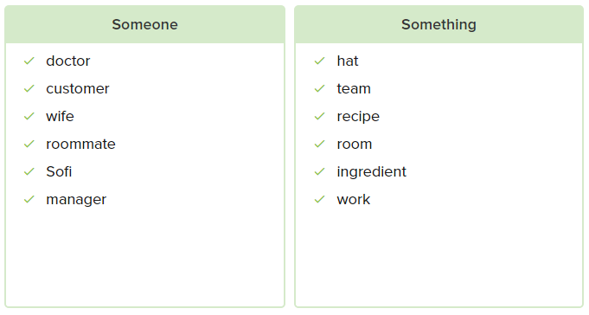

**Practice**

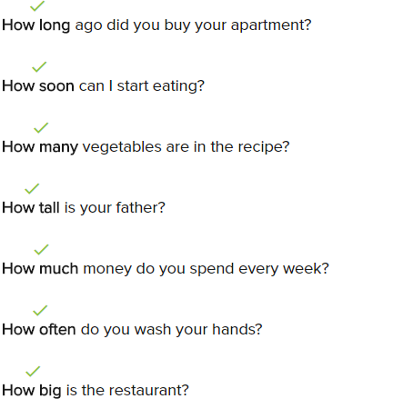

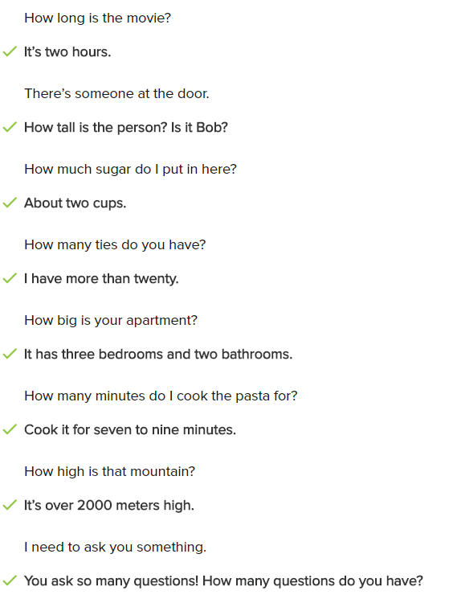

**Conversation**

Hello Liz. I hear you have a plan for a trip.

Yes, and I want to ask you something.

I glad to help. What do you want to know?

England is really expensive. How much money do I need to take?

When I was there 400$ per day it good.

Wow! I didn't how expensive it was!

Well you don’t know that much, to be don’t stay a best hotel

Do you know someone who can tell me where the cheap hotels are?

Yes. I know someone who work in small hotel I can give you his number.

That’s great. London is so big! how many friends do you have there?

Three friends. And my sister lives in _ . You can go see her

How long does it take to get there?

It takes about an hour by train.

Great. When I get back I can bring you something special to thank you for your help.

**Exercise**

Do you need my help to fix the computer?

->Yes. Something is wrong with it.

How long is the movie?

->Three hours.

There is someone at the door for you.

->Please tell him to come in.

I want to eat something. Can I have your soup?

I have a new coat.

->How much is it?

How many apples do you need?

**->**Please buy ten.

Someone is here to see you.

I am sorry. I need more time to finish this.

->How much time do you think you need?

**23.3.2**

How are you?

I’m good

How was your morning?

Oh, Sofi. It my schedule everyday is the same

Is it?

Yes, E**very morning I wake up and get out the bed**. **Then I go for I walk**. I don’t work, so I don’t have to go to work. Then I read the paper. **After that I get on the bus into the city**, I get of in Times Square. Then I walk to this restaurant to have lunch. Because I love your food

Oh, thank you. What do you do after lunch?

**I get on the bus back to my house and go home.** I read the book, watch some TV and then I get in to bed. I go to sleep

My day are the same. I get out to bed. get ready for work and the walk to work. Sometime I get on the bus. I cook all day and then I walk to my apartment and go to bed

You’re young! You need to do thing are exciting, try something new every day

You don’t try something new everyday. Do you the same thing!

Not true, I come here for lunch because you make me eat something new every time I’m here

You’re right!

So, what on the menu today?

I have a special recipe that with my grandmother. Can I make it for you?

Yes, please

I don’t have all of these ingredient, that one I don’t have. I try in new ingredient every time make this dishes. To see _ right one

May be I can help you find the right one

I would like that

Good! Go make me grandma recipe. I excite to try it

OK

How is it? Tell me the true

This is your grandmother recipe?

Yes

What ingredient do you use to day?

Sour cream. Is it bad?

I think you need to follow your recipe. There are good

My grandmother recipe are very good

Maybe. But you aren’t your grandmother. You are you. I have to go. But I’ll see you late

Bye Eli

How does Eli feel about his life?

->It’s the same every day.

Why does Eli go to the restaurant every day?

->He loves Sofi’s recipes.

What different thing does Eli do every day?

->He eats something new every day.

Eli tells Sofi that she needs to use her own recipes, not her grandmother’s recipes.

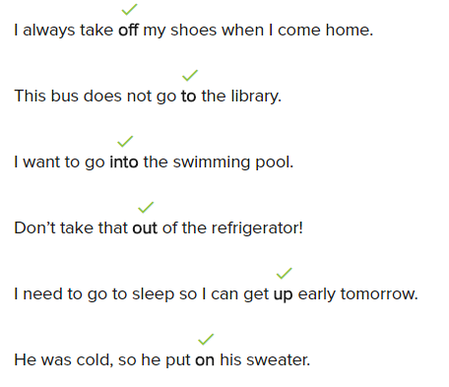

**Skills Practice**

Ben walks to work every day.

He gets on the bus at the bus stop.

I wake up and get out of bed.

Let’s go to a movie.

I want to take off my jacket.

**Conversation**

Tell me how your holiday.

It was really nice swim in the ocean every day.

How your hotel?

The hotel was perfect. The beach was right outside my window.

How is the food?

The hotel’s restaurant on beach was good. The fresh fish was delicious.

Are they sightseeing tour?

Yes, there was a tour bus to the city.

Was the city very old?

Yes, there was a museum in the park with many old things.

Are you happy back at work?

No. Now my days are same. I get out of bed, get ready for work, and take the train to work.

**Exercise**

Robert is going to the park.

My feet need to be warm, so I have to put on socks.

I put one packet of sugar in my coffee.

Every day I get off the train at Main Street.

I go to the restaurant for lunch.

I took the key out of my pocket.

Work is over. I have to get on the bus back to my house.

This is where I get on the train

**23.3.3**

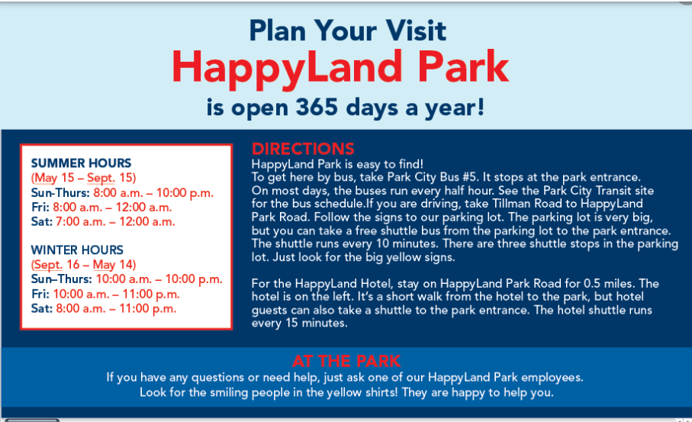

What is this website about?

-> A park

What information is on this website?

-> How to get there and when to visit

The two different schedules are for summer and winter.

How can visitors get to the park from the parking lot?

-> They can use the shuttle bus

The HappyLand Hotel is close to HappyLand Park

When visitors need help at the park, what can they do?

-> Talk to a HappyLand Park worker

**Practice**

The hotel is closed during the summer months.

Turn left and stay on Mountain Road.

The chicken soup costs nine dollars.

We can take the shuttle bus to the park.

You can checck the schedule at Belmont Station.

The temperature is below freezing in winter.

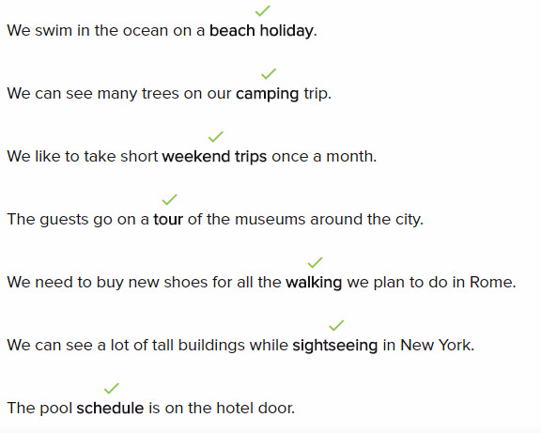\

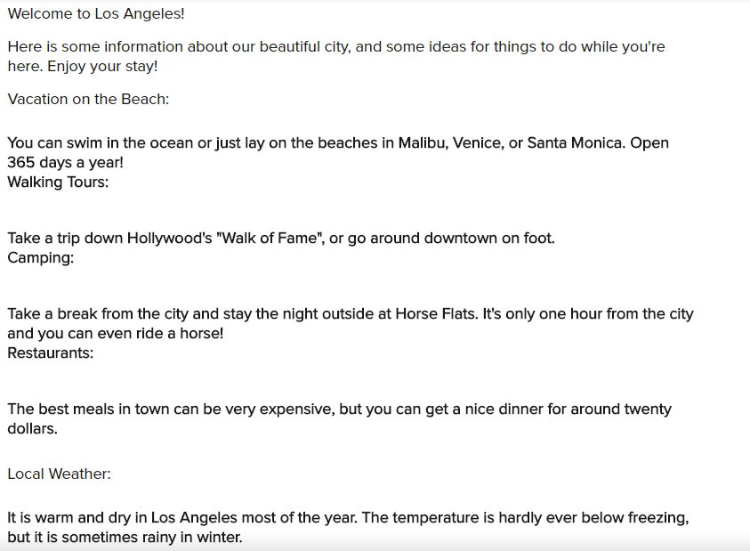

**Exercise**

Jessie: Are you planning your trip?

->David: Yes, I want to go on a tour of the city.

The museum has tours six days a week.

-> Do you like art? History? I give museum tours from Monday to Saturday. The museum is closed on Sundays.

Mike: Can I go camping on Tuesday?

->Greg: No, you can’t go camping on Tuesday.

->Camping:

-> Do you want to see some trees? I know a place where you can camp and you can cook on Wednesdays or Saturdays. You can ride horses and bicycles. You can watch birds, too.

James likes swimming in the ocean. He wants to go on a beach holiday.

The best way to see all the famous places in the city is to go on a sightseeing tour.

Tim: What day can I see a sports game?

-> Jane: There is a game every day.

-> Sports:

-> I can get you cheap tickets to all sports games. I can get you baseball tickets, football tickets, or whatever you want. You can see a game any day of the week.

Karim: I only have time to travel on Saturday and Sunday.

->Hamman: Take a short weekend trip.

Walking tours good for seeing the city and exercising at the same time.

You can take Dennis’ bus to the hotel.

-> From Airport to Hotel:

The taxi is expensive, and the train is slow. Dennis can meet you at the airport and take you to the hotel. He has a small bus

**Lesson Exercises**

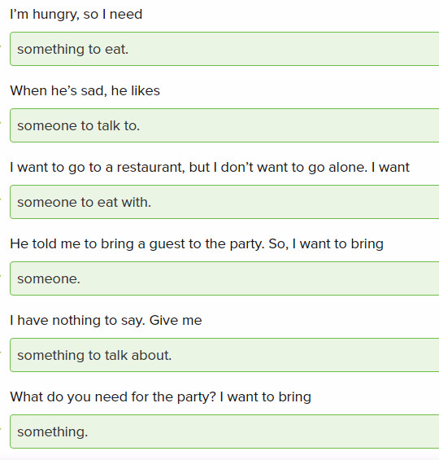

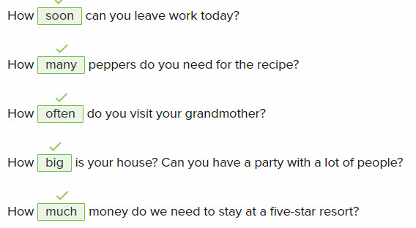

Jen, get off the bus in front of the museum. I’ll meet you at the bus stop there, and we can enter the museum together.

Enter the building on the first floor, and then walk up to the third floor. My office is there.



Take the tomatoes out of the fridge, and give them to me.

I get on the train and sit down

Put all the shopping bags **in** the car, please.

Mary: Let’s go **to** that new restaurant downtown.

-> Julie: Good idea. What time do you want to meet there?

John: The weather is so hot today. I have to **take off** my sweater. I can’t wear it anymore!

I like going for a walk in the park every morning.

**1/10**

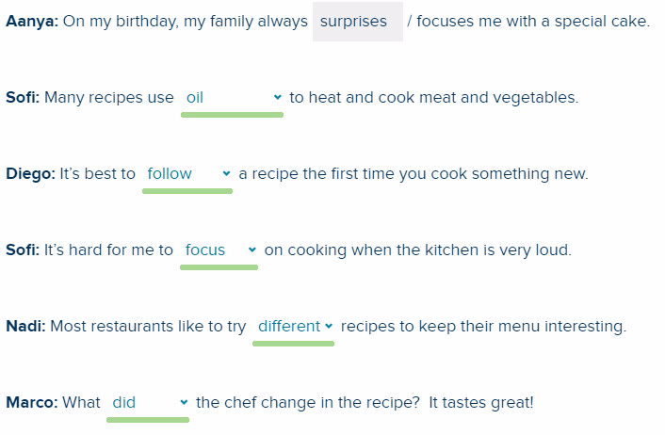

**2/10**

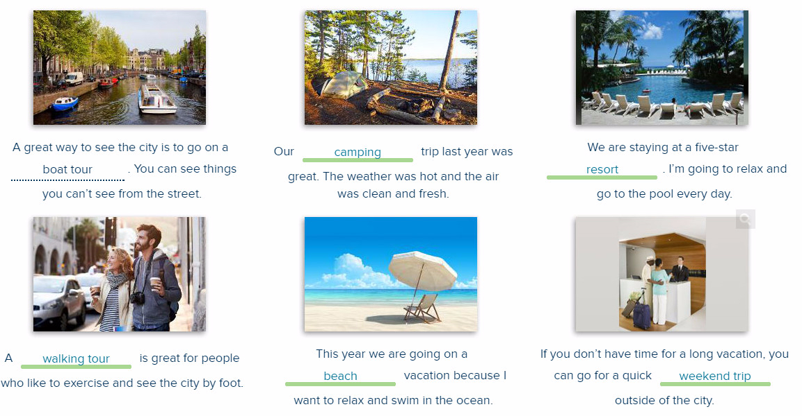

**3/10**

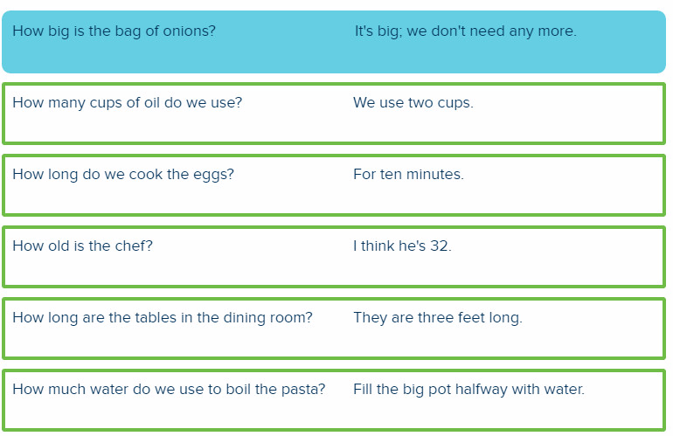

**4/10**

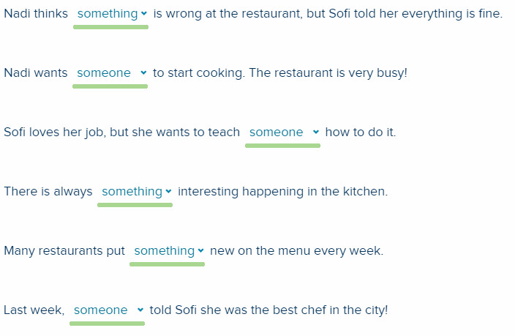

**5/10**

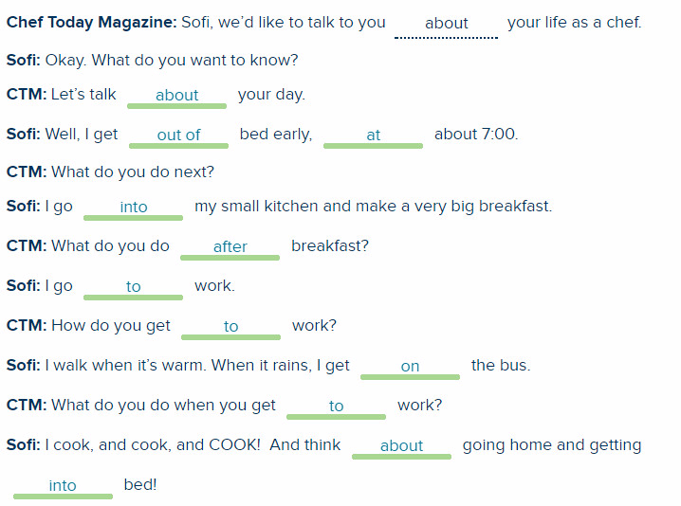

**6/10**

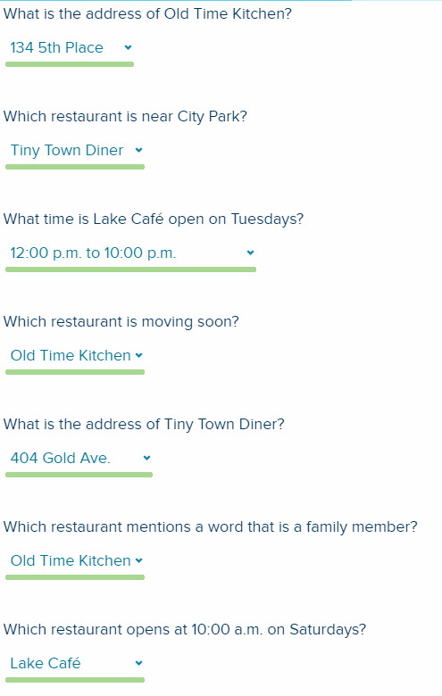

**7/10**

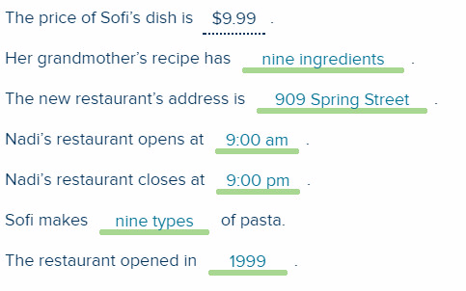

**8/10**

Aanya: Marco, can I ask you something?

Marco: Sure. What do you need to know?

Aanya: I'm planning a trip to Rome. I heard it's expensive. How much money do I need?

Marco: Hmm I think $500 a day is good.

Aanya: Wow! That IS expensive!

Marco: Well, you don't need this much if you stay in a small hotel.

Aanya: Good. Do you know someone who can tell me where the small hotels are?

Marco: Yes. I know someone who can help you. I have friends in Rome.

Aanya: Thank you. How many friends do you have in Rome?

Marco: I have three friends there. They can take you on a tour around the city.

Aanya: I'd love that! I'm going to bring them something from America.

Marco: Great. They love presents!

Aanya: So, how long do you think I need to stay in Rome to see everything?

Marco: You can never see everything in Rome in one trip. But you need to stay a week to see all the best places.

**9/10**

What time does the Green Line train leave?

It leaves at 4:25.

What’s the address of the train station?

It’s 425 Park Ave.

What time does the restaurant open?

The restaurant opens at 3 p.m.

How long does it take you to get to work?

It takes me 45 minutes to get to work.

How often do you go to the gym?

I go to the gym three days a week.

How much is the train ticket?

The train ticket is $4.25.

How big is your house?

My house is small. It has only two bedrooms.

**10/10**

Write about yourself. Use the questions below to help you.

What's your name?

How old are you?

Where do you live?

What do you do in the morning, afternoon, and evening?

How do you get to school or work?

How long does it take you to get to school or work?

Do you have children?

How old are they?

How many friends do you have?

What do they do?

What is something you love doing?

What is something you don't like doing?

My name is Kenji. I’m 30 years old. I live in Tokyo. I wake up every morning at 6 a.m. I get out of bed and go to the park to run. After that, I make breakfast, get dressed, and go to work. I work in Tokyo, so I go to work by train. It takes me about an hour to get to work. I work in an office. I’m a businessman. I’m very busy. During the week, I work until 6 p.m. On weekends, I go to the pool and visit my family. I’m married. My wife’s name is Yoko. I have a daughter. She’s two years old. My wife stays with her when I’m at work. I don’t have many friends. My best friend is Taka and his wife. We often go to the movies. We also go on vacations together. We love going to the beach. One thing I love doing is riding my bicycle. I ride every weekend. Driving is something I don’t like doing. There are always many cars in Tokyo. I like taking the train.